UPI FRAUD DETECTION SYSTEM
Abstract
The UPI Fraud Detection System is a machine learning and statistical analysis project designed to identify suspicious UPI transactions. The system analyzes transaction patterns, detects anomalies, identifies outliers, and predicts fraudulent activities using data analytics and machine learning techniques.
Introduction
Unified Payments Interface (UPI) has become one of the most widely used digital payment systems. With the increase in online transactions, fraudulent activities have also increased. The objective of this project is to analyze transaction data and identify potential fraud transactions using statistical methods and machine learning algorithms.
Objectives
- Detect fraudulent UPI transactions.
- Analyze transaction patterns.
- Identify statistical outliers.
- Generate fraud risk scores.
- Improve transaction security through predictive analysis.
Dataset Description
The dataset contains information related to UPI transactions such as:
- Transaction ID
- User ID
- Transaction Amount
- Transaction Velocity
- Receiver Account Age
- Fraud Label (is fraud)
The dataset is cleaned and processed before analysis.

Data Preprocessing
The following preprocessing steps were performed:
- Removal of duplicate records.
- Handling missing values.
- Data type conversion.
- Statistical validation.
- Feature selection.
Descriptive Statistical Analysis
The dataset was analysed using:
- Mean
- Median
- Standard Deviation
- Minimum Value
- Maximum Value
- Correlation Analysis
These statistics help understand transaction behavior and fraud patterns.
Outlier Detection
IQR Method
The Interquartile Range (IQR) method was used to detect unusual transaction amounts.
Formula:
IQR = Q3 − Q1
Lower Bound = Q1 − 1.5 × IQR
Upper Bound = Q3 + 1.5 × IQR
Transactions outside these limits were considered outliers.
Z-Score Method
The Z-score technique was used to identify extreme values.
Formula:
Z = (X − Mean) / Standard Deviation
Transactions with |Z| > 3 were considered abnormal.
Fraud Pattern Investigation
The following indicators were analyzed:
- High transaction amounts.
- High transaction velocity.
- New receiver accounts.
- Repeat fraud users.
- Unusual transaction behavior.
Fraudulent transactions showed significantly different characteristics compared to legitimate transactions.
Data Visualization
The project generated multiple visualizations:
- Transaction Amount Distribution
- Fraud vs Legitimate Amount Comparison
- Receiver Account Age Distribution
- Transaction Velocity Analysis
- Outlier Detection Plots
- Correlation Heatmap
- Feature Importance Graph
These visualizations helped understand fraud trends effectively.
Machine Learning Models
The following machine learning algorithms were implemented:
Random Forest Classifier
Advantages:
- High accuracy.
- Handles large datasets.
- Robust against overfitting.
Logistic Regression
Advantages:
- Fast execution.
- Easy interpretation.
- Suitable for binary classification.
Decision Tree Classifier
Advantages:
- Simple visualization.
- Easy rule extraction.
- Effective for fraud classification.
Performance Evaluation
The models were evaluated using:
- Accuracy
- Precision
- Recall
- F1-Score
- Confusion Matrix
These metrics measured the effectiveness of fraud detection.
Business Insights
The analysis produced the following recommendations:
- Monitor high-value transactions.
- Detect abnormal transaction velocity.
- Verify newly created accounts.
- Implement multi-factor authentication.
- Enable real-time fraud alerts.
- Continuously monitor suspicious users.
- Apply machine learning-based risk scoring.
- Strengthen transaction verification procedures.
Coding
import pandas as pd
import matplotlib.pyplot as plt

# Load Dataset
df = pd.read_csv("fraud_dataset.csv")

# Basic Information
print("Total Transactions:", len(df))
print("Fraud Transactions:", df["is_fraud"].sum())

# Fraud Percentage
fraud_percent = (df["is_fraud"].sum() / len(df)) * 100
print("Fraud Percentage:", round(fraud_percent, 2), "%")

# Average Amount
print("Average Transaction Amount:", round(df["amount"].mean(), 2))

# High Value Transactions
high_value = df[df["amount"] > df["amount"].quantile(0.95)]
print("High Value Transactions:", len(high_value))

# Fraud Rate by Device Flag
device_fraud = df.groupby("unusual_device_flag")["is_fraud"].mean() * 100
print("\nFraud Rate by Device:")
print(device_fraud)

# Graph 1: Fraud vs Normal
df["is_fraud"].value_counts().plot(kind="bar")
plt.title("Fraud vs Normal Transactions")
plt.xlabel("Fraud Label")
plt.ylabel("Count")
plt.show()

# Graph 2: Transaction Amount Distribution
plt.hist(df["amount"], bins=20)
plt.title("Transaction Amount Distribution")
plt.xlabel("Amount")
plt.ylabel("Frequency")
plt.show()

print("\nUPI Fraud Detection Analysis Completed")
Output

Distribution
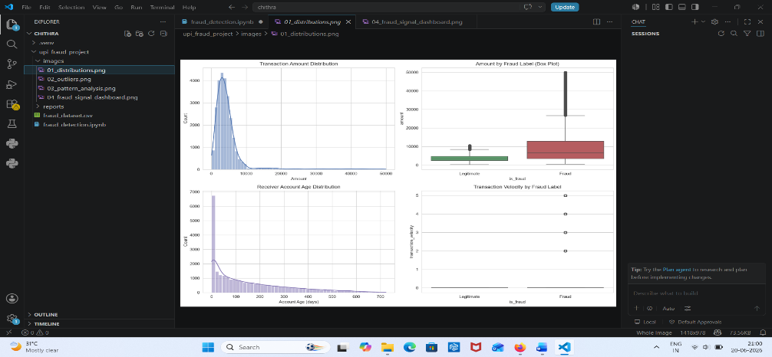

Outliners
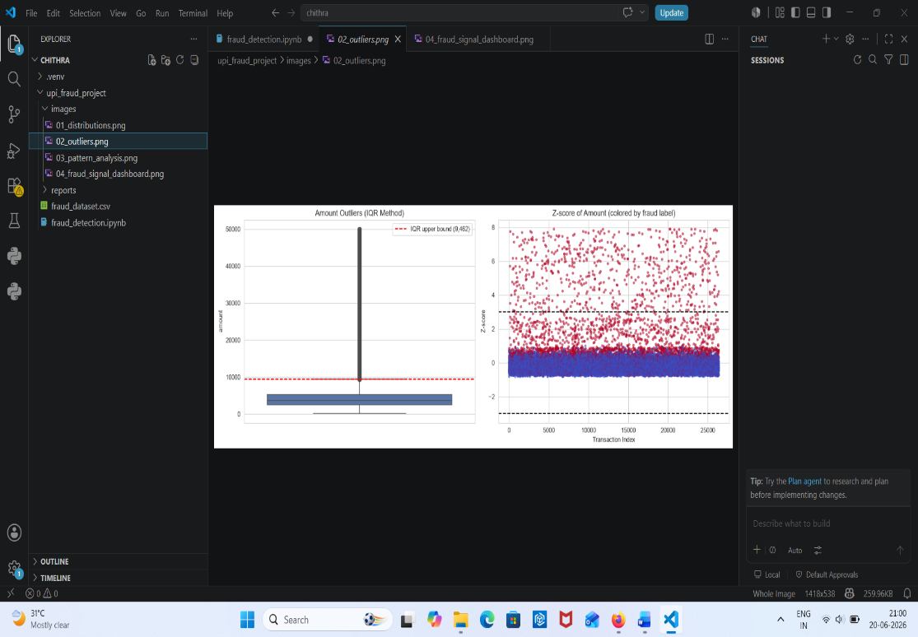

Pattern analysis
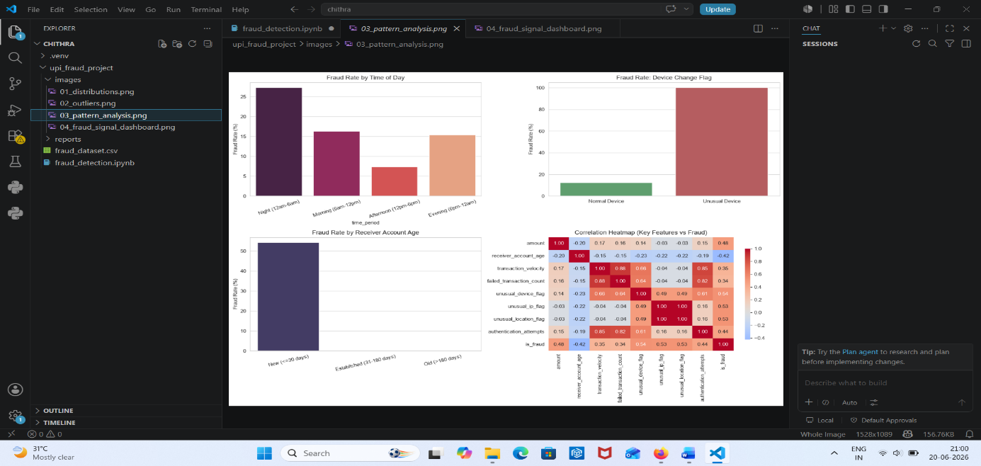

Fraud signal dashboard
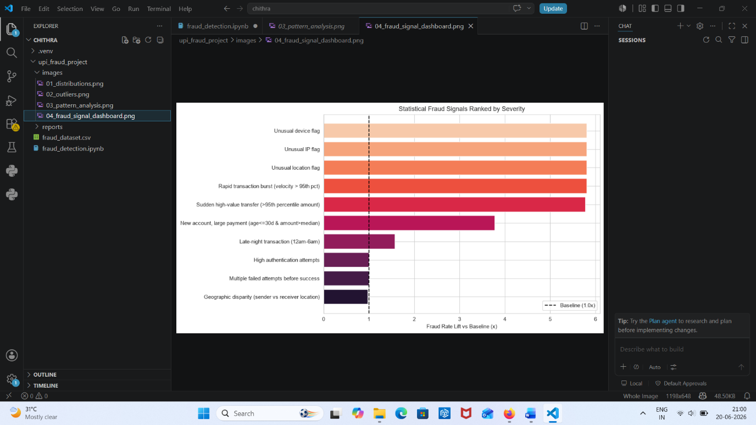

Future Enhancements
- Real-time fraud detection.
- Deep learning-based models.
- Live transaction monitoring dashboard.
- SMS and email fraud alerts5
- Integration with banking systems

References
- Python Documentation
- Pandas Documentation
- NumPy Documentation
- Scikit-Learn Documentation
- Matplotlib Documentation
- Research Papers on Digital Payment Fraud Detection

